<https://www.youtube.com/channel/UCs79SiE-PD3AUy2clzrSlog>

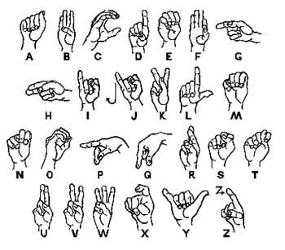

**PRONOUNS**

**HE, SHE, ITS**



**ME, I**

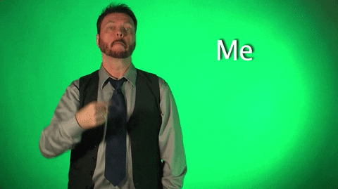

**MINE, MY, BELONGS TO ME**



**OURS**



**HIS, HERS, ITS**



**YOU, YOURS, BELONGS TO YOU**



**THEIRS, YOURS**



**VERBS**

**ALWAYS**

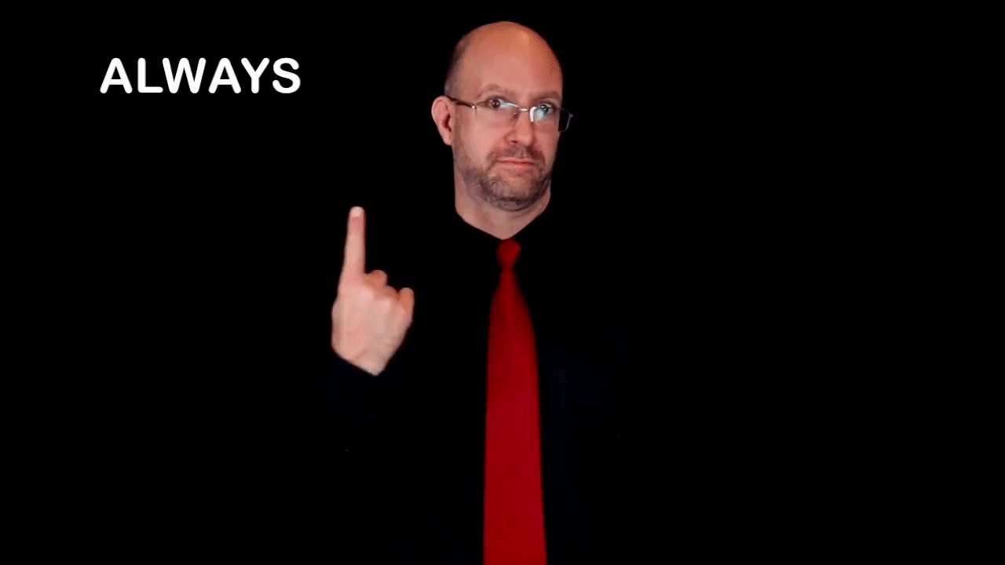

**GIVE**

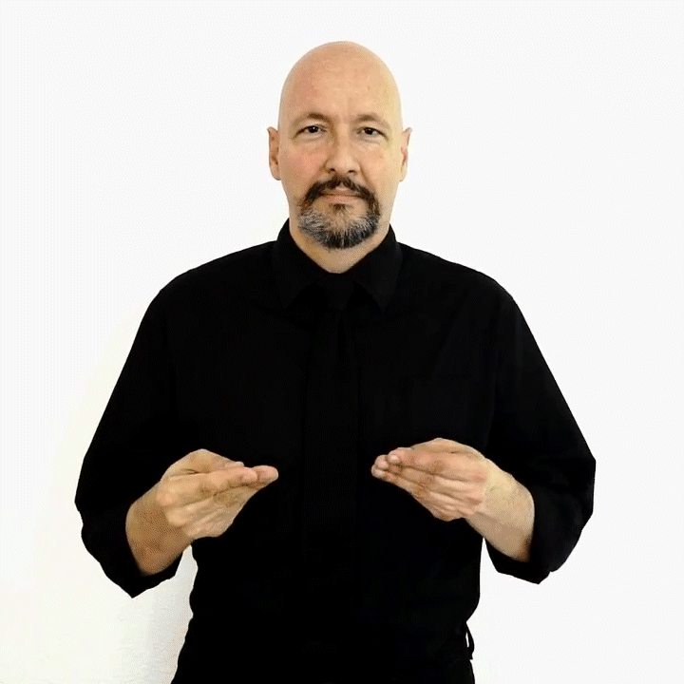

**HELP**



**PLEASE**



**TALK**



**EAT**



**COLOURS**



**RED**



**BLUE**

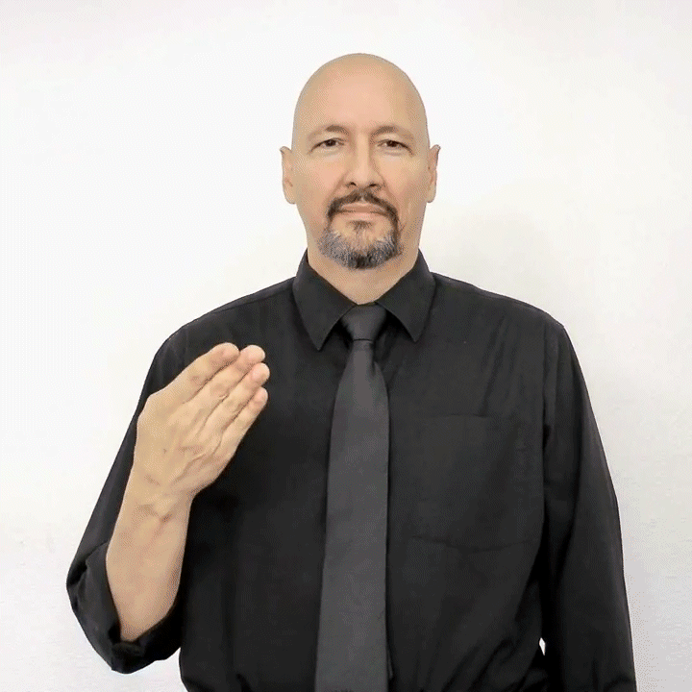

**GREEN**

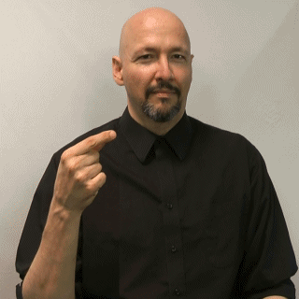

**YELLOW**

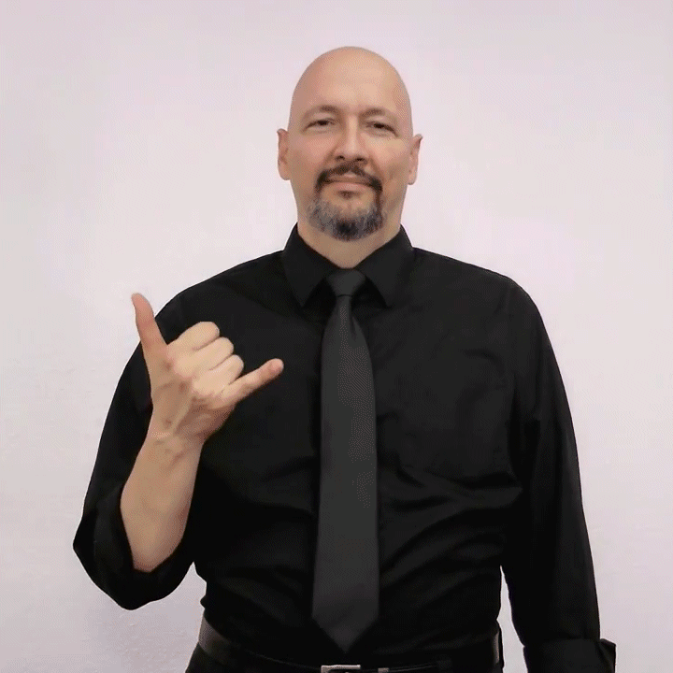

**ORANGE**



**BLACK**

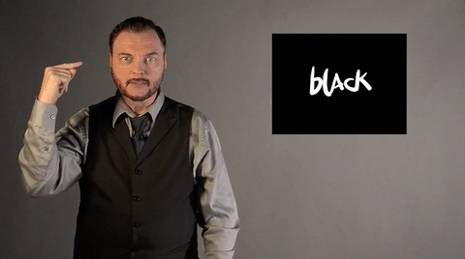

**WHITE**



**RAINBOW**



**SIMPLE SENTENCES**

Do note that your facial expression and body language matters for each sentence. Without the right facial expression, your sentences might be misleading.

**I DON’T KNOW**



**ARE YOU ALRIGHT?**



**HOW ARE YOU DOING?**



**THANK YOU SO MUCH**



**I LIKE IT**



**WHAT’S UP?**



**NICE TO MEET YOU**



**IT IS FAKE!**

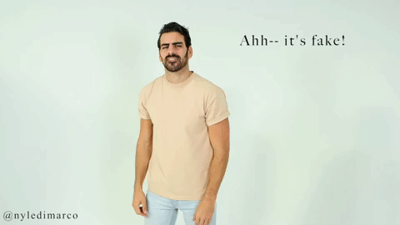

**YOU’RE WELCOME**

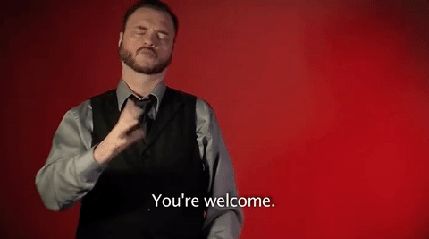

**SEE YOU LATER**

